KEY **Unit 7 Outline– Chemical Reactions**

**Study Guide** (This is only a partial review- use your labs, book assignments, and worksheets too)

1. Given the following equations, determine if a **physical change** or **chemical change** has occurred **&** **explain** how you know: ESA!!

a) CO2 (s) + H2O → H2CO3 (g) Chemical- different substances in reactants and products

b) CO2 (s) → CO2 (g) Physical – Same substance in reactants and products, it just had a faze change.

1. Can you read a chemical equation? Identify the **reactants**, **products** & all the **bolded** **symbols** below:

AgNO3 **(aq)** **+** MgBr2 (aq) **🡪**  AgBr **(s)** + __ Mg(NO3)2  ESA!!

Reactants Products

**(aq)** = aqueous… means dissolved in water **+=** combined with **🡪**turns into/ produces **(s)** = solid

1. 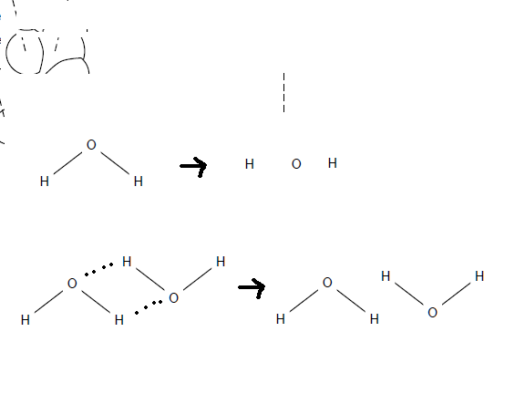On the image, identify:
   1. the bonds that break during a chemical reaction & also name.

_____ = strong bonds that break in chemical reactions and separate atoms from each other.   
Ex: water is broken into H & O

* 1. the bonds that break during a physical reaction & also name.

…. = hydrogen bonds that are weak, these break during physical changes

When something changes from a solid to a liquid.   
Ex: water molecules break away from each other.

|  |  |  |
| --- | --- | --- |
| 1. **Name** ESA!! | **Rule? (ex: 2 non-metals)** | **Formula** |
| **a. barium hydroxide** | **metal + polyatomic ion** | **Ba(OH)2** |
| **b. trisulfur tetraoxide** | **2 nonmetals** | **S3O4** |
| **c. diarsenic trisulfide** | **2 nonmetals** | **As2S3** |
| **d. sodium carbonate** | **metal + polyatomic ion** | **Na2CO3** |
| **e. ammonium sulfate** | **both polyatomic ions** | **(NH4)2SO4** |
| **f. Bromine** | **Diatomic molecule** | **Br2** |
| **g. Gold (I) phosphate** | **Transition metal + polyatomic ion** | **Au3PO4** |
| **h. Barium Carbonate** | **metal + polyatomic ion** | **BaCO3** |

|  |  |  |  |  |  |  |
| --- | --- | --- | --- | --- | --- | --- |
| 5. | **Formula** | **Total # of atoms** | **Total number of ions** | **Charge on cation** | **Charge on anion** | **Molar mass** |
|  | Mg(NO3)2 | 9 | 3 | Mg 2+ | (NO3)-1 | 148g/ mole (periodic table) |
|  | Al(OH)3 | 7 | 4 | Al 3+ | (OH)-1 | 1. g/ mole |

6. What are **4** potential indicators of a chemical reaction?

* 2 liquids make a solid (precipitate)
* color change
* gas
* heat or light given off

|  |  |  |
| --- | --- | --- |
| 7. ESA!!***Balance*** the following equations & ***ID*** the type of reaction: | Chem. Reaction Type: | Will the reaction occur? Why? |
| a. 2 CO + O2 🡪2 CO2 | synthesis | Yes, always do |
| b. 2 Na + 2 H2O 🡪 2 NaOH + H2 | Single | Yes, Na is higher on activities series than H |
| c. 2 AgNO3 + MgCl2 🡪 2 AgCl + Mg(NO3)2 | double | Yes, AgCl is solid |
| d. 2P2O5 🡪 4 P + 5 O2 | Decomp | Yes, always do |
| e. CH4 + 2 O2 🡪____ CO2 + 2 H2O | Combustion | Yes, always do |

8. a. What **law** in nature requires that chemical reactions be balanced? How does it work?

The Law of conservation of matter/ mass. “What goes in must come out.”

b. **For: 2 Al(OH)3** What is the 2 called & why is it there? What is the 3 called & why is it there?

* 2 is a coefficient, these are written in order to balance and equation
* 3 is a subscript that is used to correctly write the formula. Swap and drop the charge of 3 from Al.

1. List the 7 **diatomic** elements & explain why they are diatomic.

H2, N2, O2, I2, F2, Cl2, Br2… All these elements bond with themselves to make the octet rule instead of being a single, monoatomic atom like the noble gases and metals.

1. Write the correct ***formulas, state of matter, and equations, & balance:*** 
   1. Aqueous iron (III) nitrate reacts with a solution of ammonium sulfate to yield aqueous ammonium nitrate and aqueous iron (III) sulfate.

2Fe(NO3)3 (aq) + 3(NH4)2SO4 🡪 6NH4 NO3 (aq) + Fe2(SO4)3 (aq) (double replacement)

* 1. Solid mercury (I) oxide breaks down to form liquid mercury and oxygen gas.

2Hg2O (s) 🡪 4Hg (l) + O2 (g) (decomposition)

11. Complete the following chart.

|  |  |
| --- | --- |
| Reactants Predict the Products  (make sure to balance equations) | |
| a. ___2_ Fe(NO3)3 + _3___ Pb 🡪 | 3Pb(NO3)2 + 2Fe | |
| (Pb 2+ is most common)  b. ___1_ C5H12 + __8__ O2 🡪 | 6 H2O + 5 CO2 | |
| c. ­­__3_NaNO3 + _1__FeBr3 🡪 | Fe(NO3)­3 + 3 NaBr | |

12. Based on the **solubility chart**, identify if the substances are a **solid (precipitate)** or **aqueous**:

a. ZnCO3  b. K3PO4 c. Ca(OH)2 d. Al2(SO4)3

**solid aq solid aq**

13. Based on the **activity series** which element is more likely to replace the other in a compound?

a. **K** and Na b. **Al** and Ni c. I and **F**